### CRM Application for Jewel Management

**College Name :** Sri Vasavi College,

Erode-638316.

**College Code :** bru17.

**TEAM ID :** NM2025TMID23275.

**TEAM MEMBERS :** 4.

**Team LeaderName :** SURYAPRAKASH.A

**Email :** aasuryaprakash@gamil.com

**Team Member :** KAVINRAJ.B

**Email :** kavinraj2768@gmail.com

**Team Member :** BHARATH.J

**Email :** bharatherode2006@gmail.com

**Team Member :** ABISHEK.S.R

**Email :** abishek25062006@gmail.com

**INTRODUCTION**

The Jewel Inventory System is a comprehensive software Solution designed to streamline and manage the inventory and sales processes of a jewellery store or a jewellery manufacturer. The system aims to provide an efficient and user-friendly solution to track and control the inventory of various jewellery items, maintain accurate records, and facilitate seamless sales transactions.

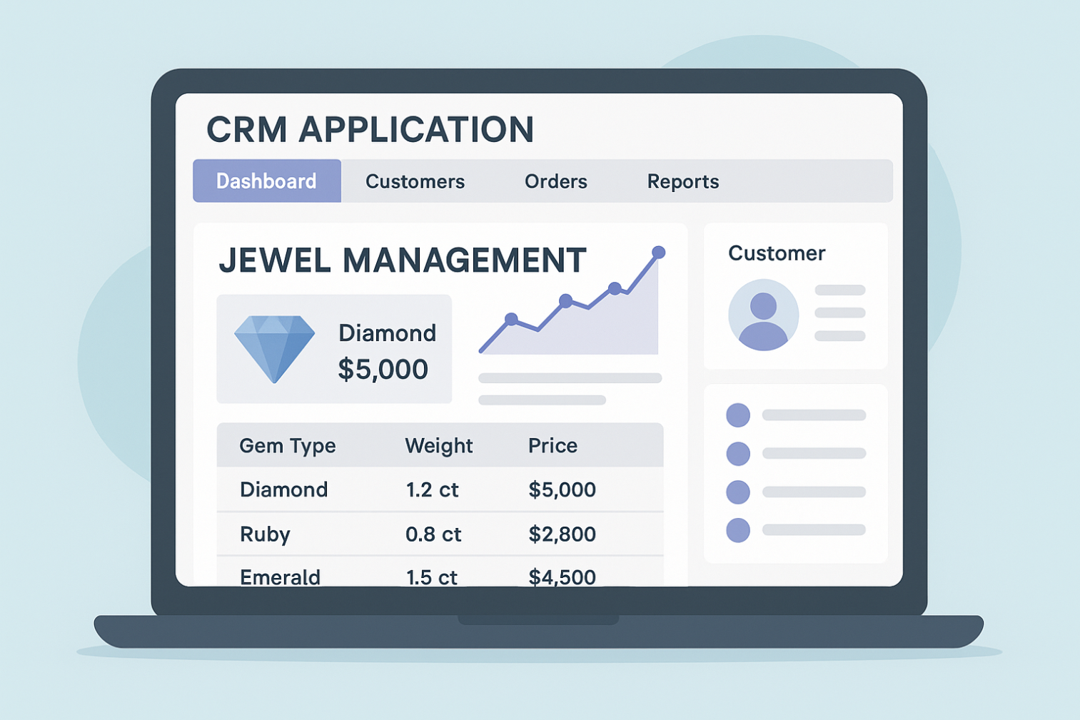

**Purpose:**

A CRM application for jewel management helps jewelry businesses handle everything in one place. It stores customer details and purchase history, keeps track of jewelry items like type, value, and availability, and monitors sales and orders. It also gives useful reports and insights, making it easier to engage with customers, reduce manual work, and grow the business more efficiently.

**DEVELOPMENT PHASE**

**Creating Developer Account:**

* By using this URL -  <https://developer.salesforce.com/signup>

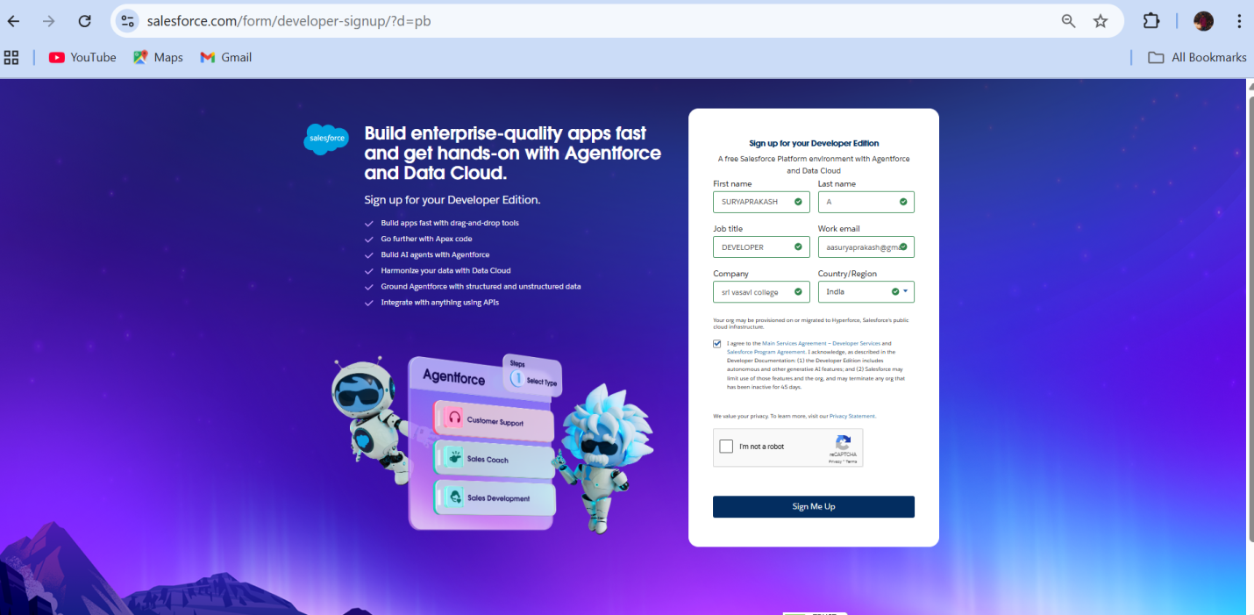

* Created objects: Jewel Customer, Item, Customer Order, Price, Billing

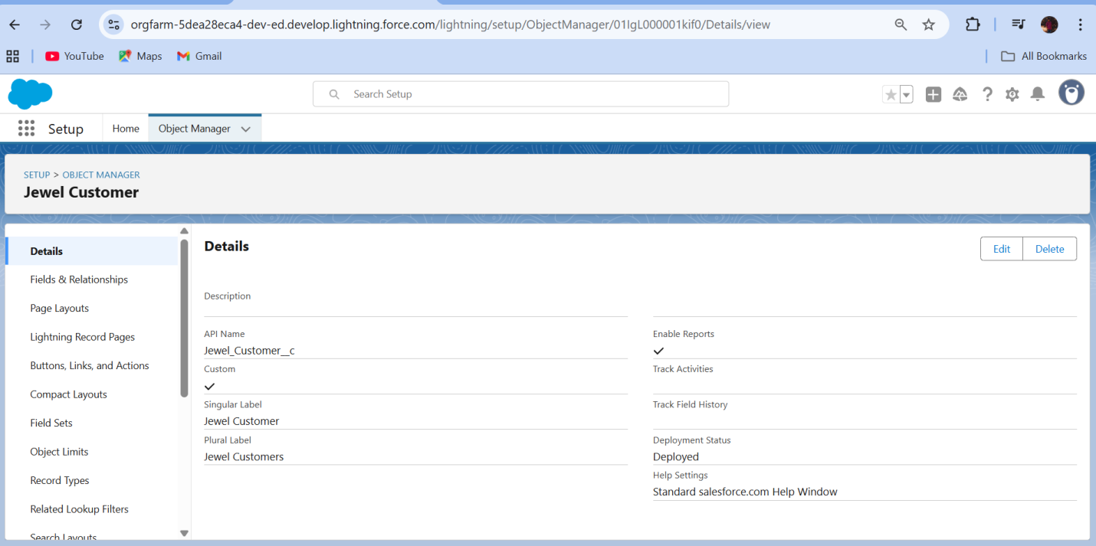

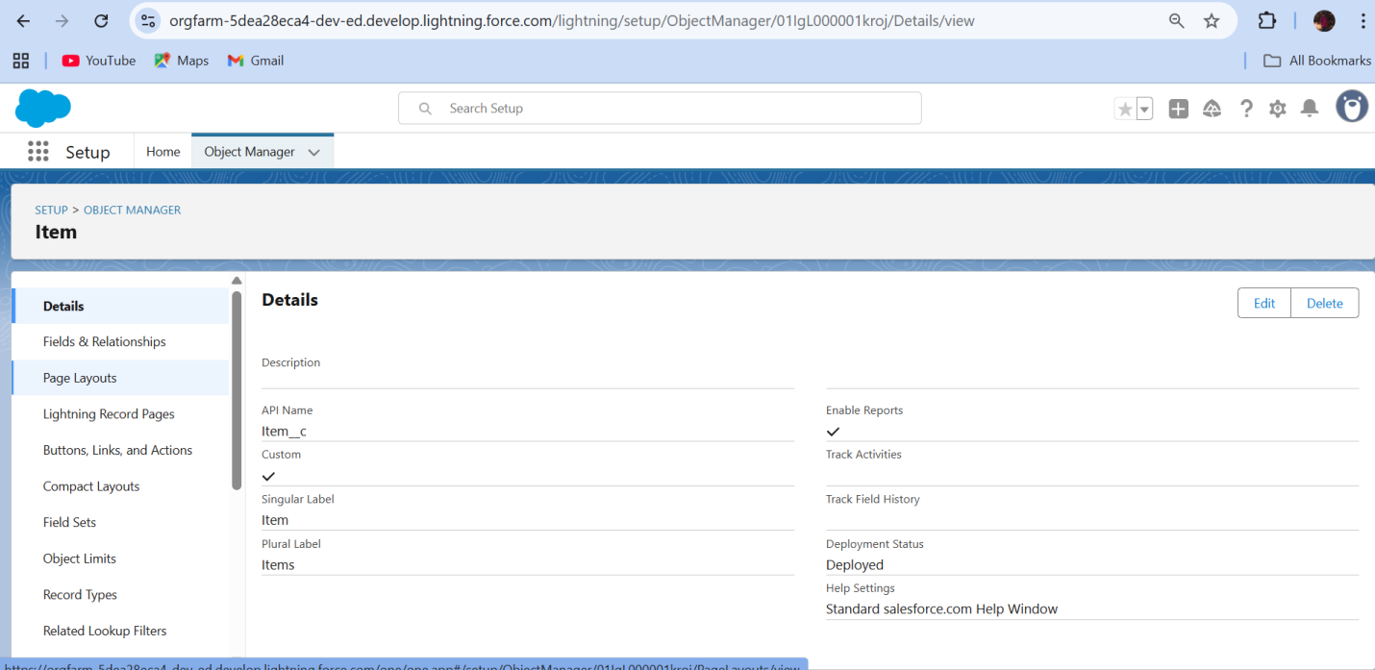

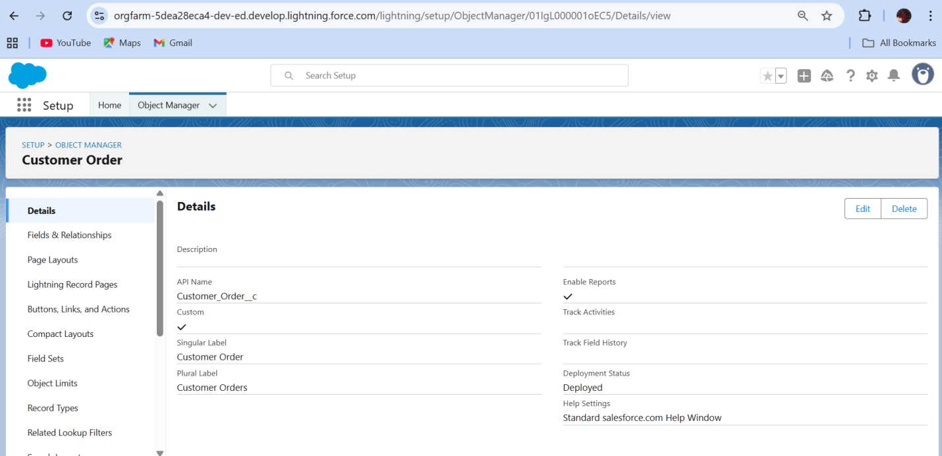

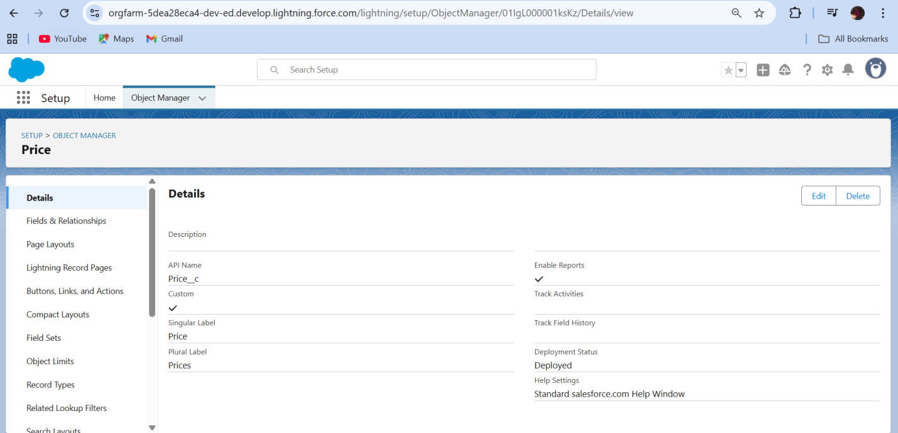

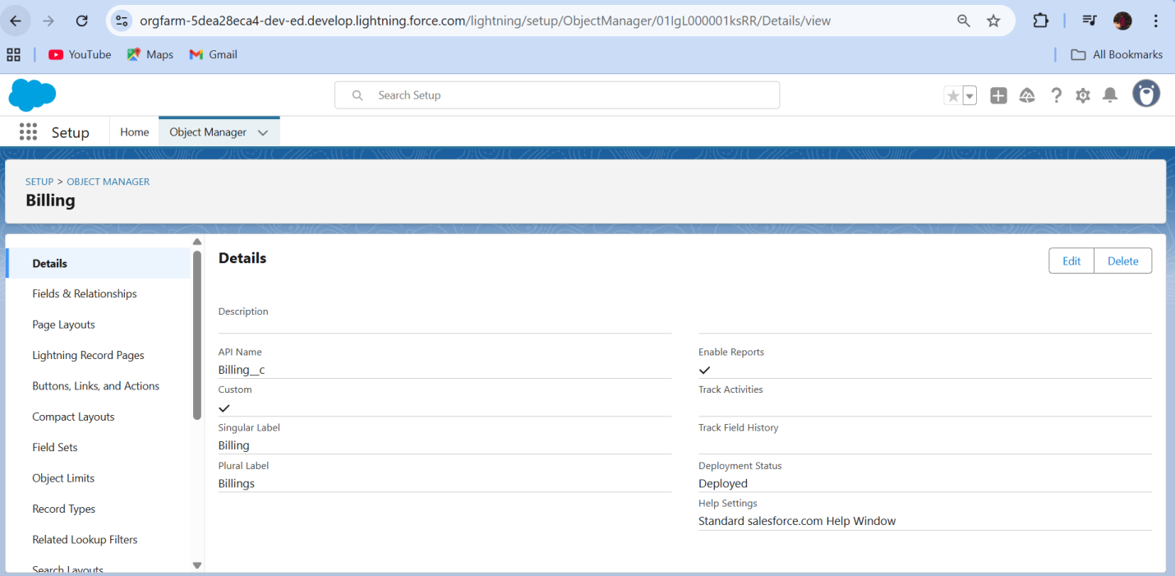

* Created Tabs: Jewel Customer, Item,  Customer Order, Price, Billing.

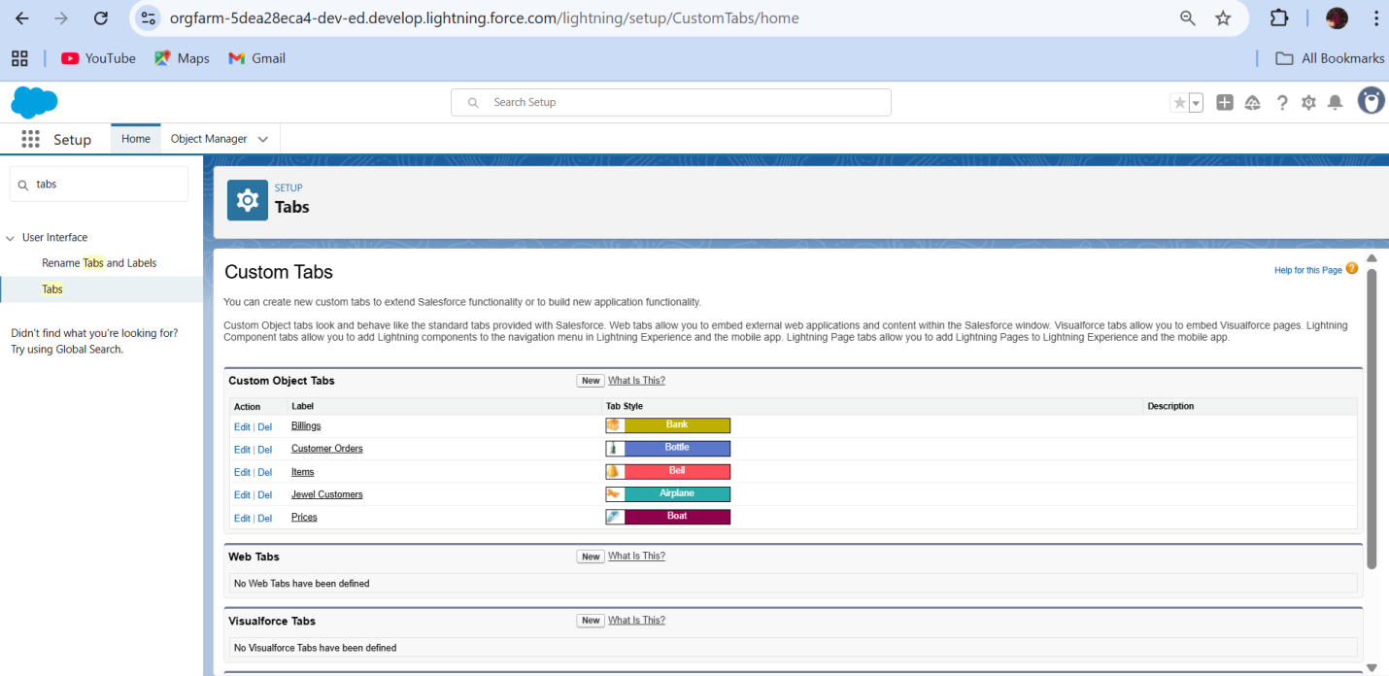

* Developed Lightning App with relevant tabs

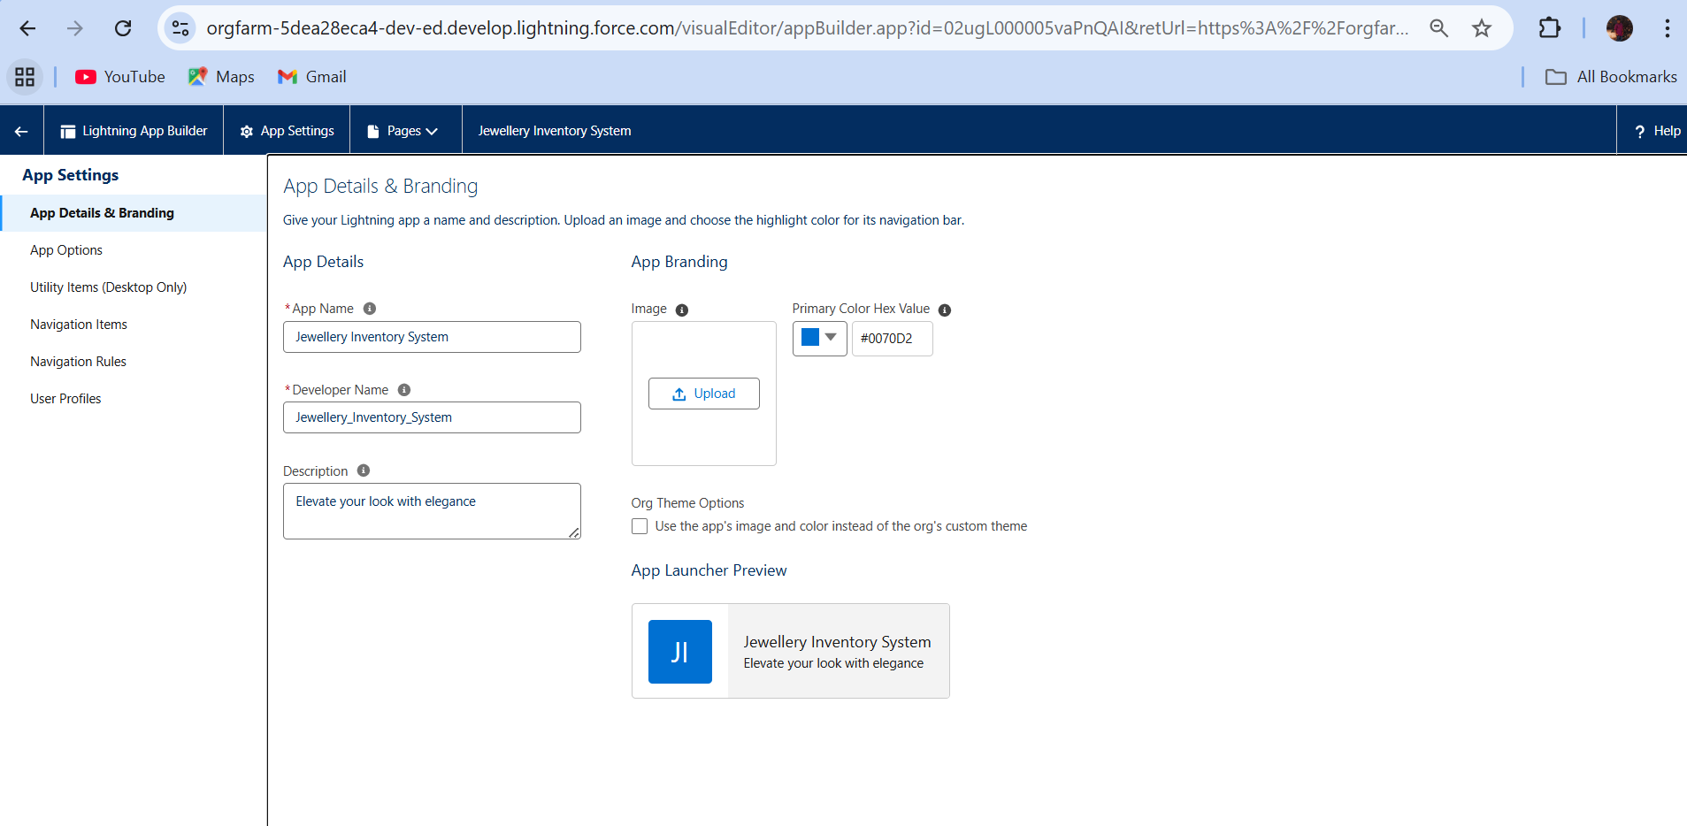

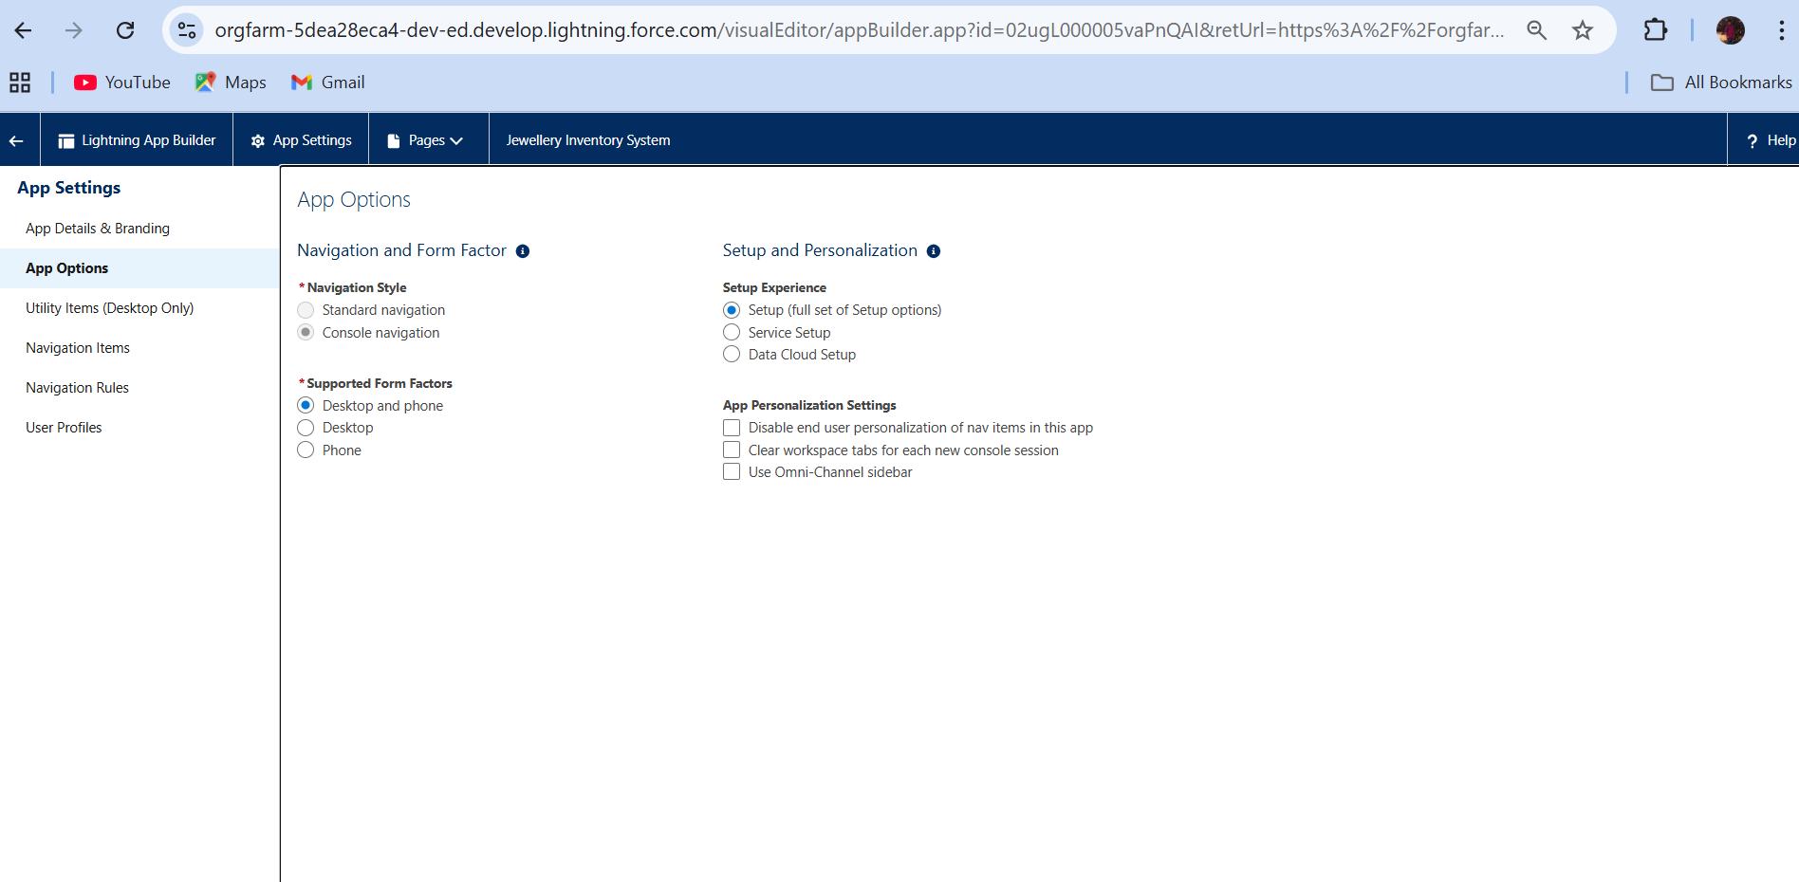

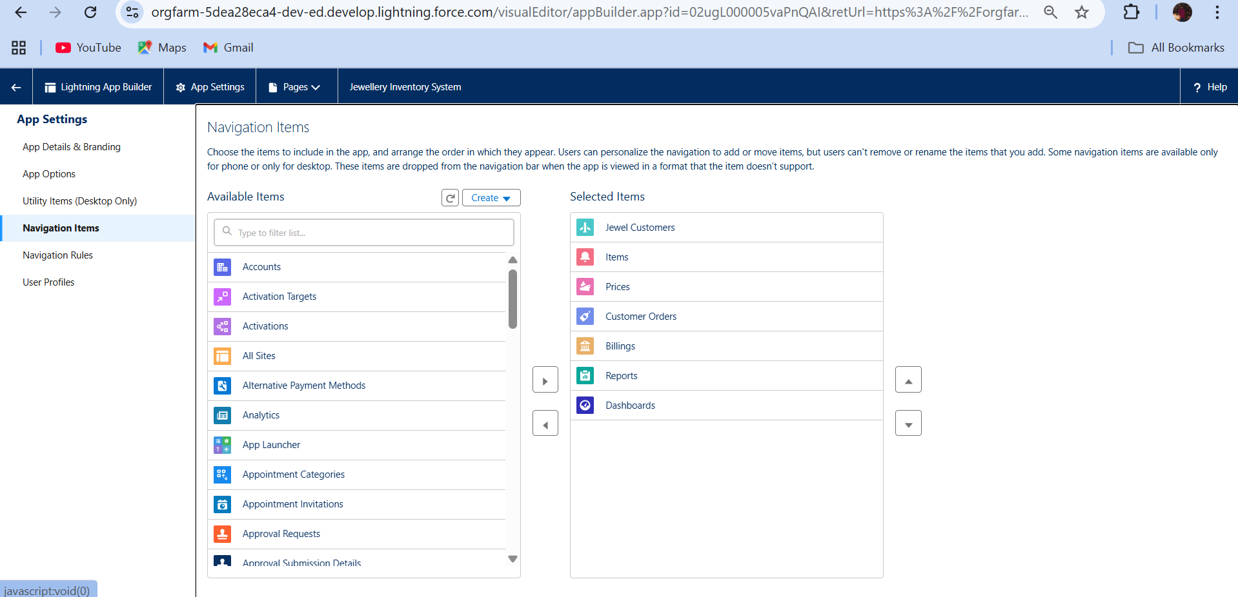

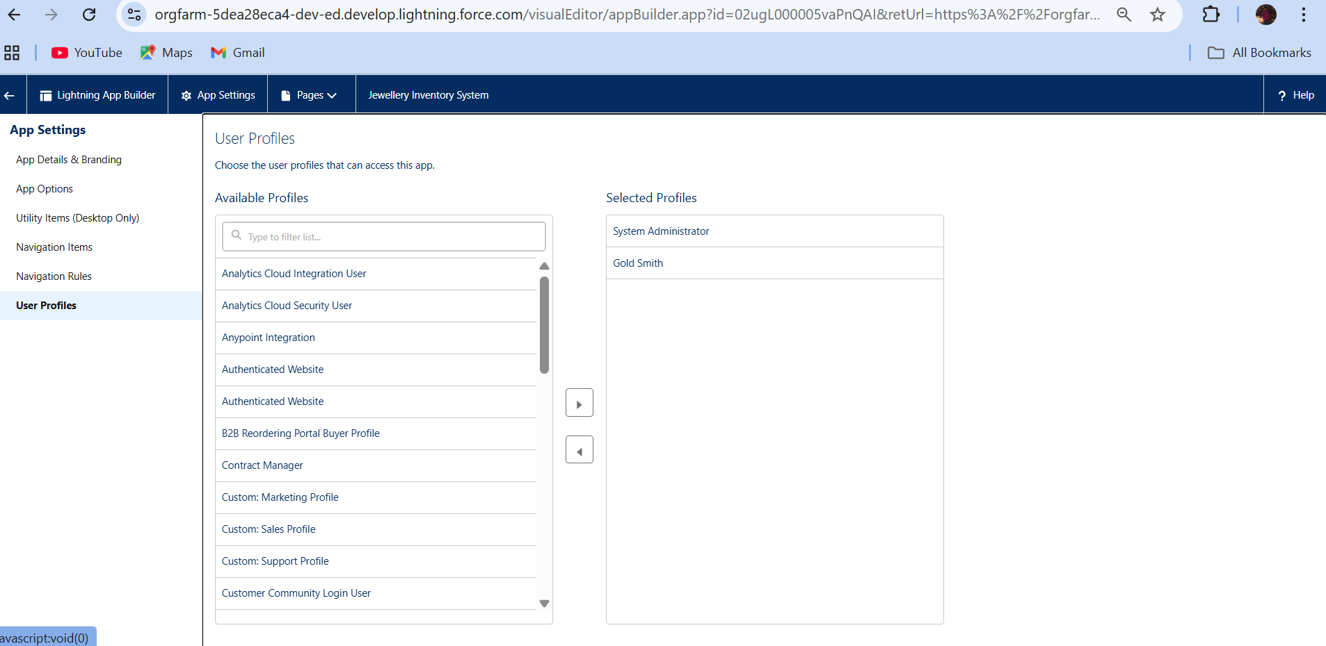

* Configured fields and relationships

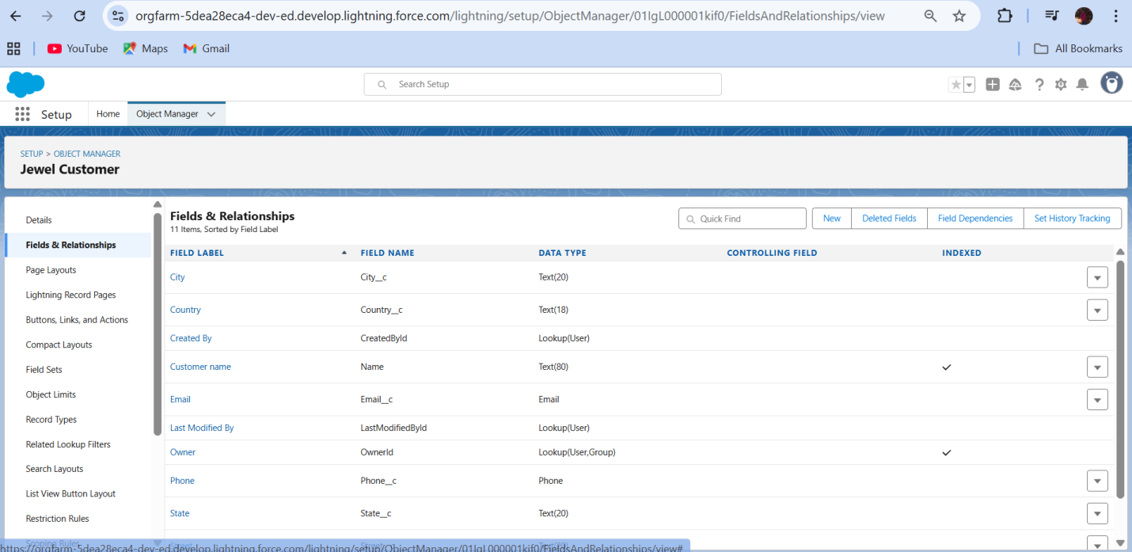

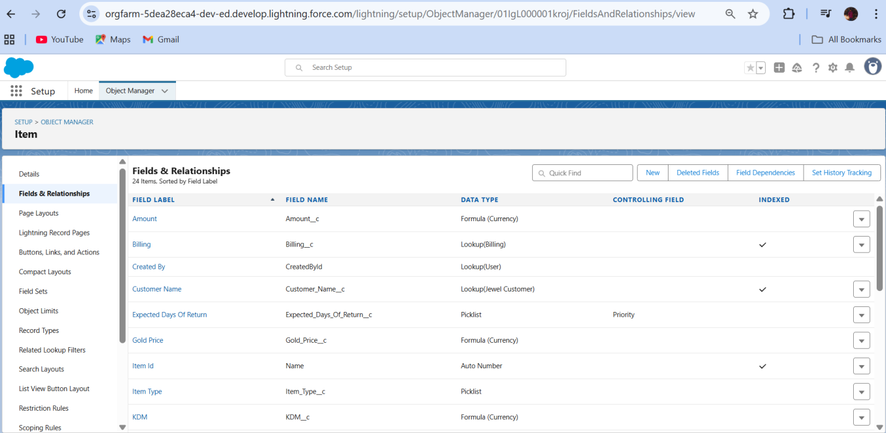

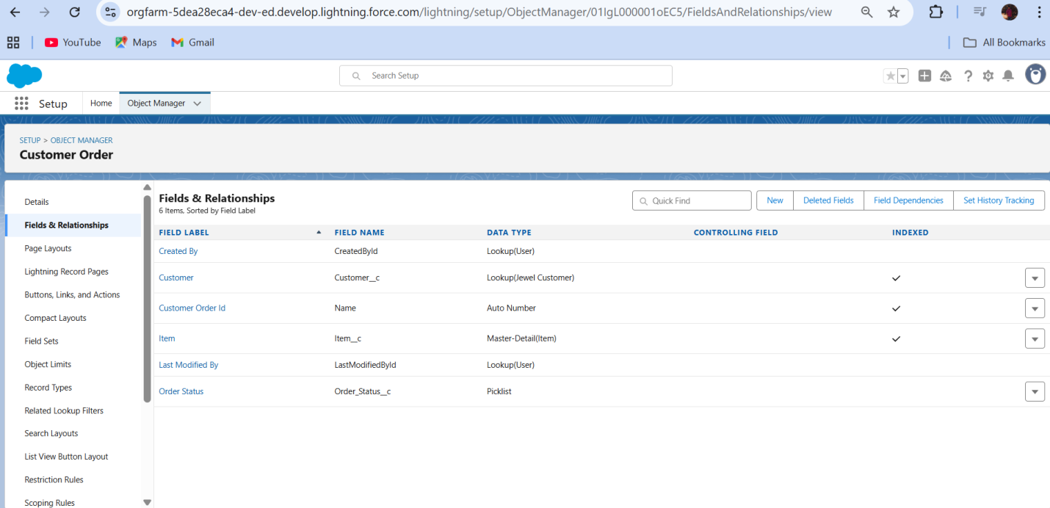

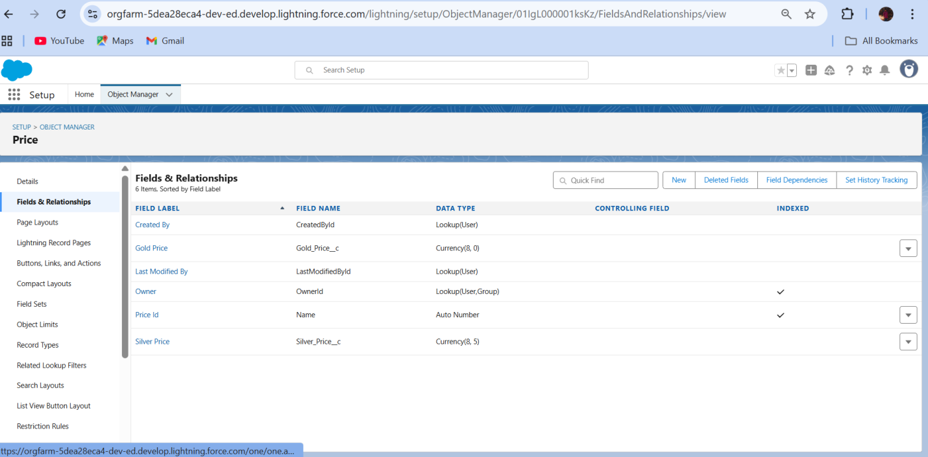

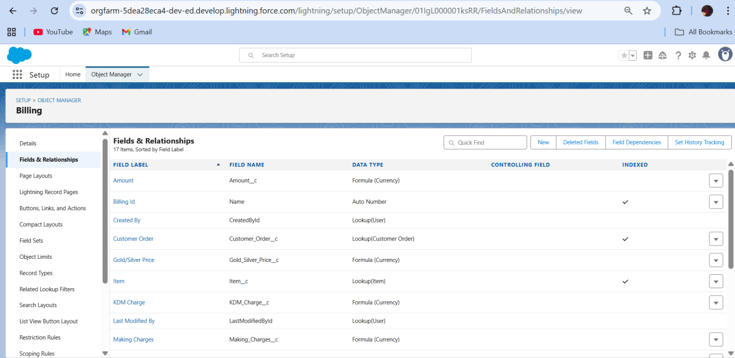

* Created profiles:

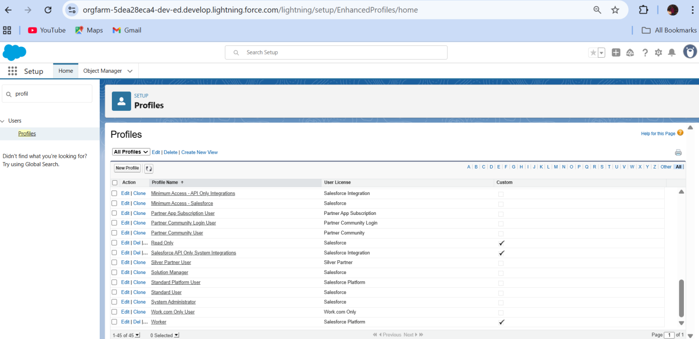

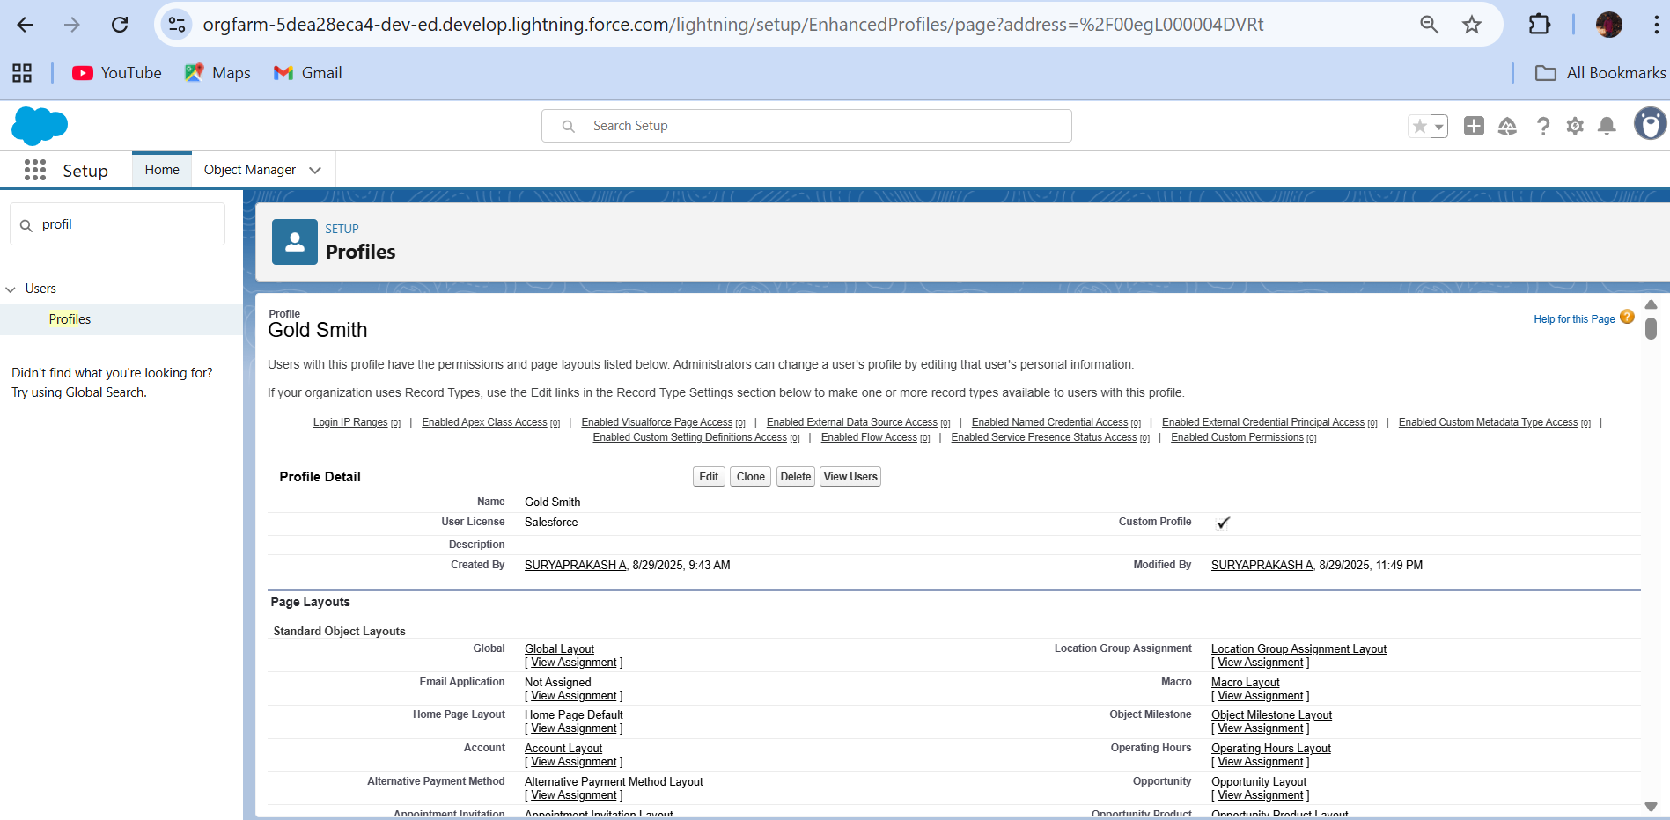

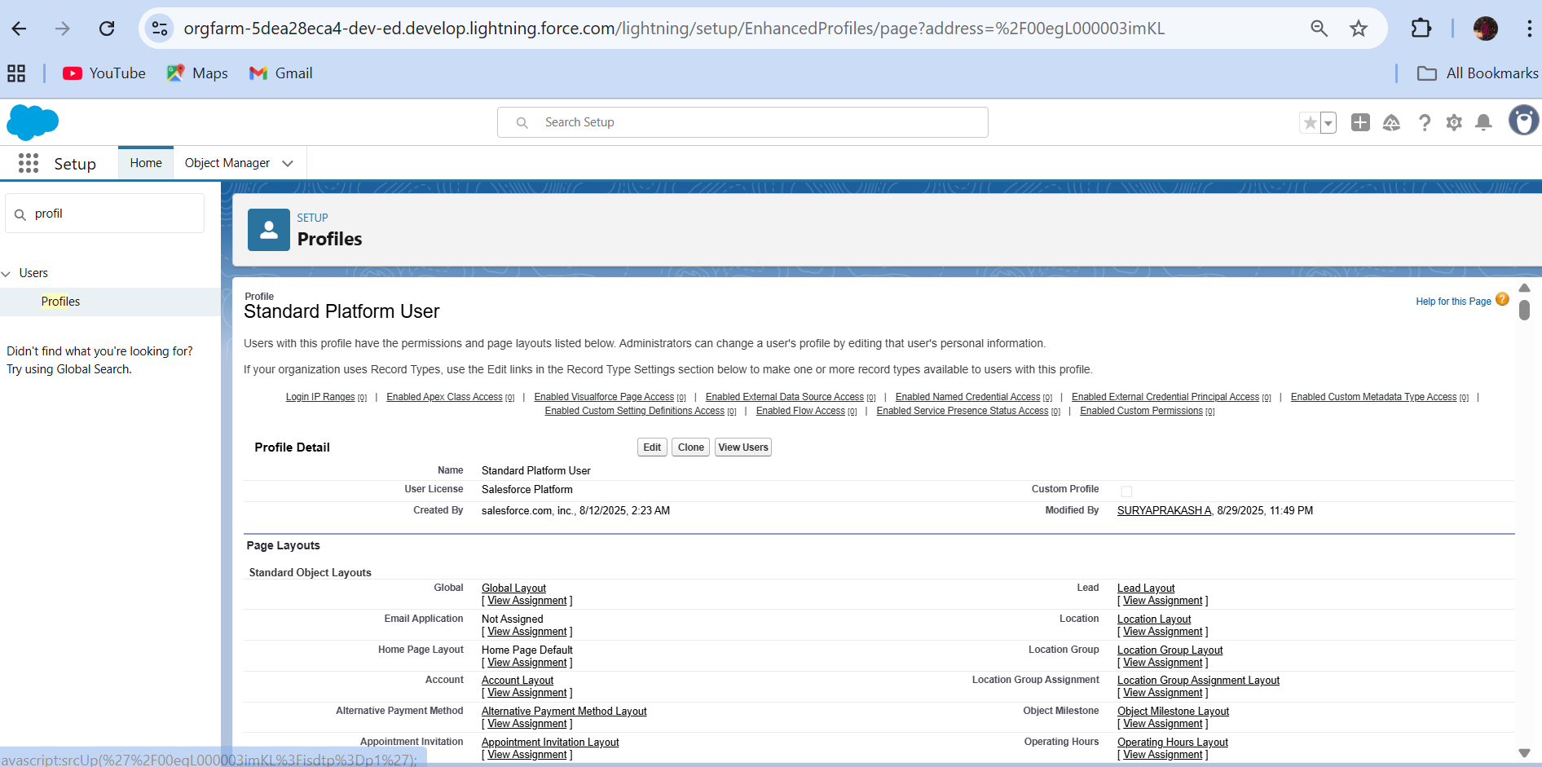

* Created Roles:

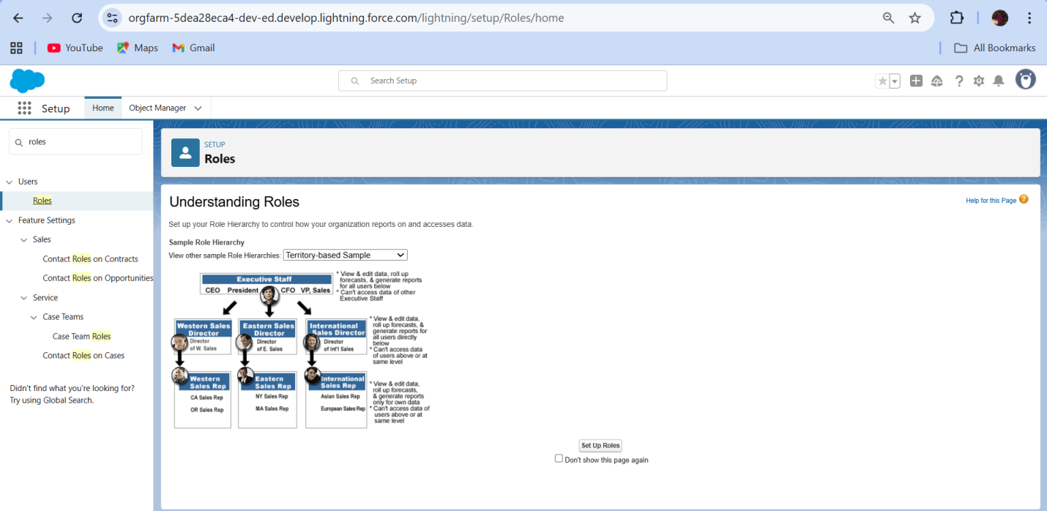

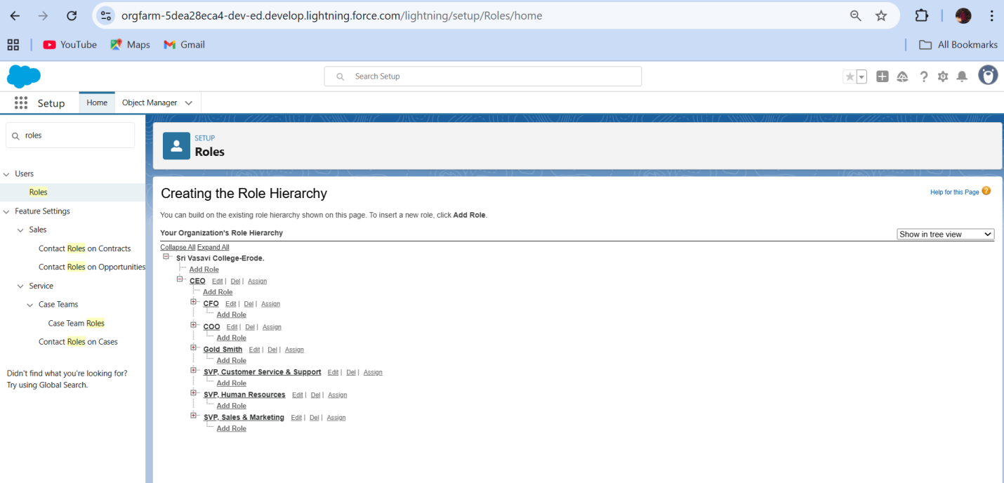

### Created Users:

### 

### 

### Created page layouts:

### 

### Created Record Type:

### 

### Created permission sets:

### 

### Created Trigger Handler class:

### 

### Created the trigger:

### 

### User Adoption

### Created Records:

### 

### Create Reports:

### 

### 

### Created Dashboard:

### 

### Created Flow:

### 

### CONCLUSION:

### The CRM application for jewel management makes jewelry business tasks easier by bringing customer details, inventory, and sales into one system. It saves time, improves accuracy, helps understand business performance, and supports growth, making it a useful tool for the jewelry industry.

**APPENDIX**

### Source Code: Provided in Apex Classes and Triggers

### UpdatePaidAmountTriggerHandler.apxc

public class UpdatePaidAmountTriggerHandler {

    public static void handleBeforeInsert(List<Billing__c> newBillings) {

        for (Billing__c billing : newBillings) {

            billing.Paid_Amount__c = billing.Paying_Amount__c;

        }

    }

    public static void handleBeforeUpdate(Map<Id, Billing__c> oldBillingsMap, List<Billing__c> updatedBillings) {

        for (Billing__c billing : updatedBillings) {

            Billing__c oldBilling = oldBillingsMap.get(billing.Id);

            Decimal oldPaidAmount = oldBilling.Paid_Amount__c;

            billing.Paid_Amount__c = oldPaidAmount + billing.Paying_Amount__c;

        }

    }

}

### UpdatePaidAmountTrigger.apxt

trigger UpdatePaidAmountTrigger on Billing__c (before insert, before update) {

    if (Trigger.isInsert) {

        UpdatePaidAmountTriggerHandler.handleBeforeInsert(Trigger.new);

    } else if (Trigger.isUpdate) {

        UpdatePaidAmountTriggerHandler.handleBeforeUpdate(Trigger.oldMap, Trigger.new);

    }

}